Wildlife Research Permit Background
Title: NWT Biodiversity Monitoring Program and threats boreal treeline birds
Main Investigators:
Samuel Hache, PhD  Landbird Biologist (Program Lead)  Canadian Wildlife Service  Environment and Climate Change Canada  P.O. Box 2310, 5019 – 52nd St., 4th Floor  Yellowknife, NT, X1A 2P7  Telephone 867.669.4771  Facsimile 867.873.8185  samuel.hache@ec.gc.ca | Kevin Kardynal  Wildlife Research Biologist  Science and Technology Branch  Environment and Climate Change Canada  115 Perimeter Rd  Saskatoon, SK, S7N 0X4  Telephone 306.491.2165  Kevin.Kardynal@ec.gc.ca | Brad Woodworth  Climate Change Ecologist  Government of Northwest Territories  500, 5102-50th Avenue  Yellowknife, NT X1A 2L9  Telephone 867.446.8922  brad_woodworth@gov.nt.ca

NWT Biodiversity Monitoring Program: Background context
Maintaining biodiversity is important for ecosystem health and community well-being. With ongoing impacts of climate change, human disturbance, and industry, long-term monitoring programs are required to understand the current state of and changes in wildlife populations. This, in turn, is needed to inform sound and collaboratively developed management and conservation actions. Activities proposed under this Wildlife Research Permit form part of a growing Northwest Territories Biodiversity Monitoring Program (NWTBMP); a collaborative initiative aimed at enhancing structured, passive wildlife monitoring across the Northwest Territories.
Under the NWTBMP, the two primary types of sensors currently being deployed are acoustic recording units (ARUs) and wildlife cameras. ARUs record the soundscape on a pre-programmed schedule, whereas cameras take photos when triggered by animal movements. Both sensor types can be left out on the land for an extended period of time or moved around regularly. ARUs can detect a variety of vocalizing animals, including birds, insects, mammals, and amphibians. Migratory bird data collected by ARUs helps to fulfill Environment and Climate Change Canada’s (ECCC) obligations to monitor and conserve migratory bird populations (Migratory Birds Act, 1994) and protect threatened species (Species at Risk Act, 2002). Wildlife cameras can detect a variety of medium to large-sized vertebrates, including large mammals, meso-carnivores, fur-bearing species, as well as waterfowl and other migratory and non-migratory birds. Data collected by cameras can support wildlife management, protected area planning, and landscape planning more broadly within the Northwest Territories.
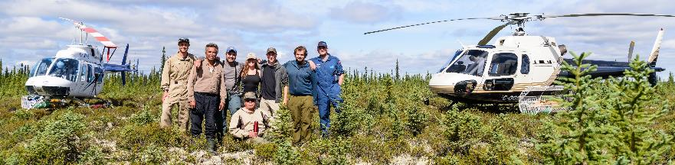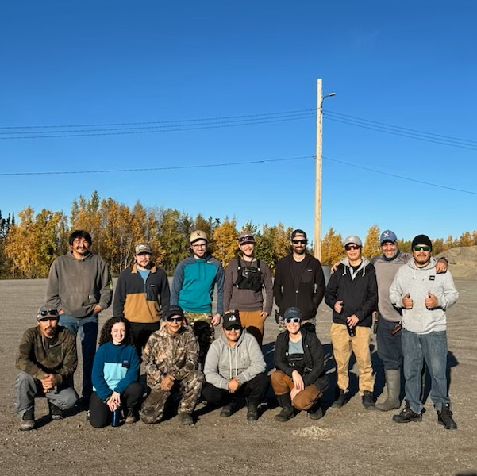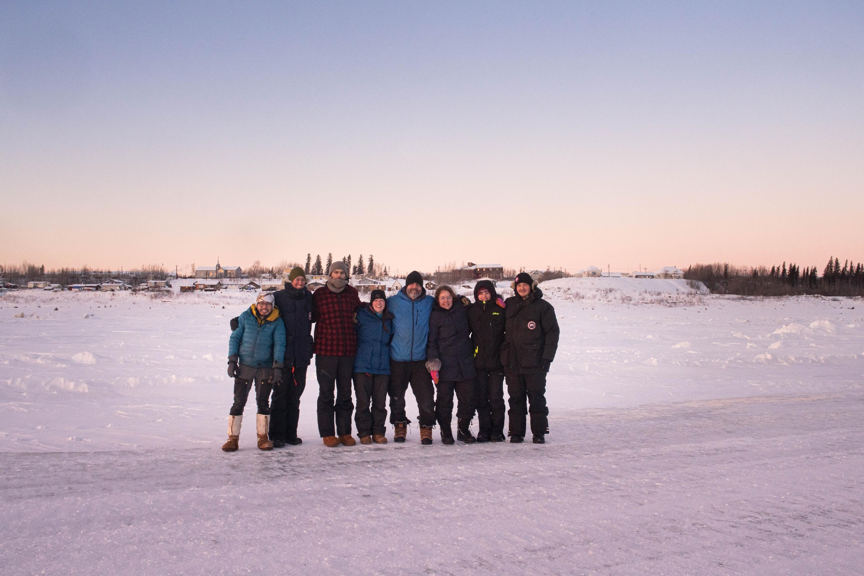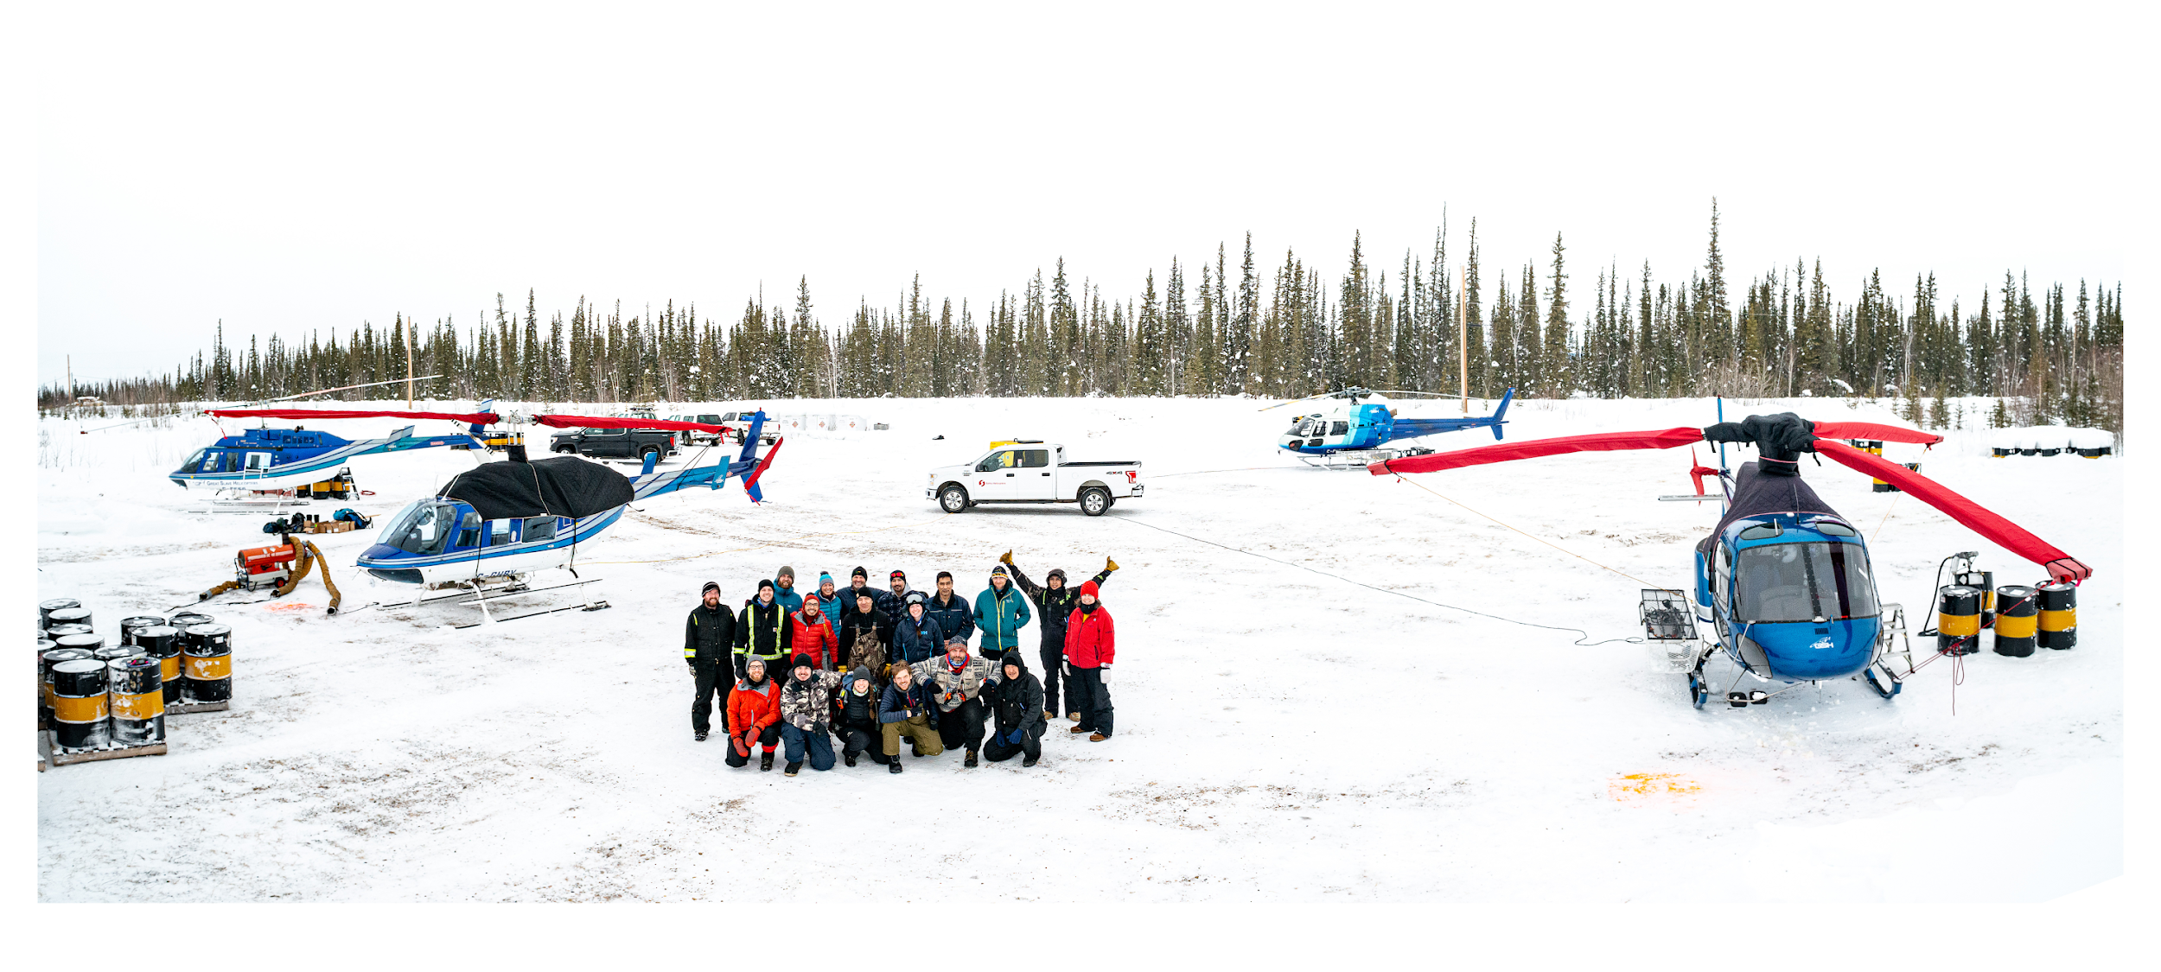

Figure 1. Examples of the implementation of the NWTBMP, where field crews comprised of staff from the Canadian Wildlife Service and Government of Northwest Territories worked with academic partners (e.g. UBC and UofA) and community guardians in Ts'udé Nilįné Tuyeta (top), Gamèti (mid-left), along the Mackenzie Valley Winter Road (mid-right), and in Edéhzhíe National Wildlife Area & Dehcho Protected Area (bottom).
The NWTBMP was first conducted in Ts’udé Nilįné Tuyeta Indigenous protected area and has since been followed by programs in Edéhzhíe Dehcho Protected Area and National Wildlife Area, Dınàgà Wek'èhodì candidate protected area, Thaidene Nëné Indigenous Protected Area, along the Sambaa K’e, Mackenzie Valley, and Tłı̨chǫ winter roads, and within ~ 100 km of the communities of Norman Wells, Fort Smith, and Gamètì (Figure 1). For most of these projects, bat meters and temperature sensors were also deployed at a subset of sampling locations. Guardians and other Indigenous partners have been actively involved in all aspects of development and implementation of these programs (Figure 1). To date, units have been deployed/retrieved at approximately 1,450 sampling units. Our goal is to continue to broaden the scope of the NWTBMP and deploy these four environmental sensors in the Gwich’in and Inuvialuit Settlement Regions and boreal treeline near Lockhart camp in June 2025 (Figure 2 & 3).
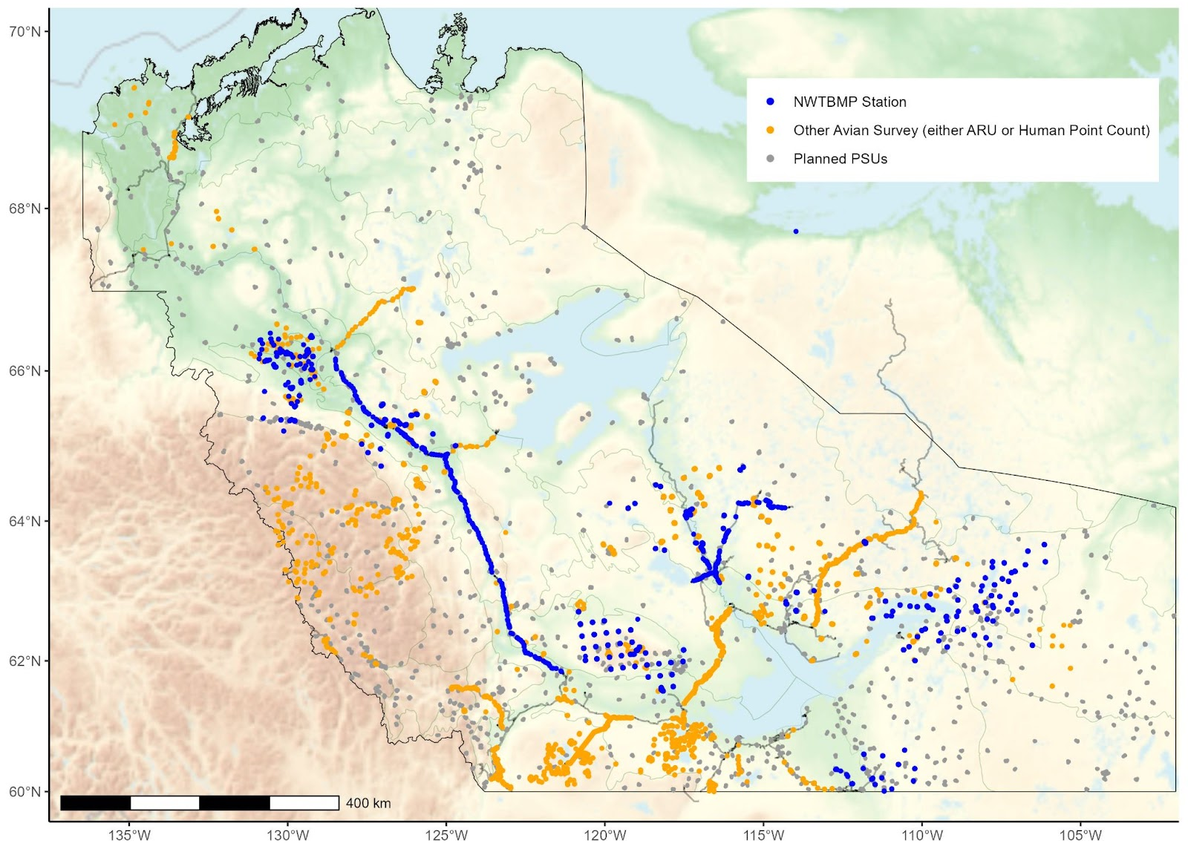
Figure 2: Study sites across NWT where the NWT Biodiversity Monitoring Program has been successfully implemented to date. In grey are targeted sampling locations without data, in blue are sampling locations where the NWTBMP has been implemented. Most of the blue points represent multi-sensor deployments (ex. ARU’s and cameras), and in yellow are other avian survey points (ARU’s-only or in-person point counts) with data.
ARUs have been deployed along the Tibbitt to Contwoyto winter road in 2015, 2016, and 2021 to collect data for avian point count surveys the subsequent summer (Figure 2 & 4).
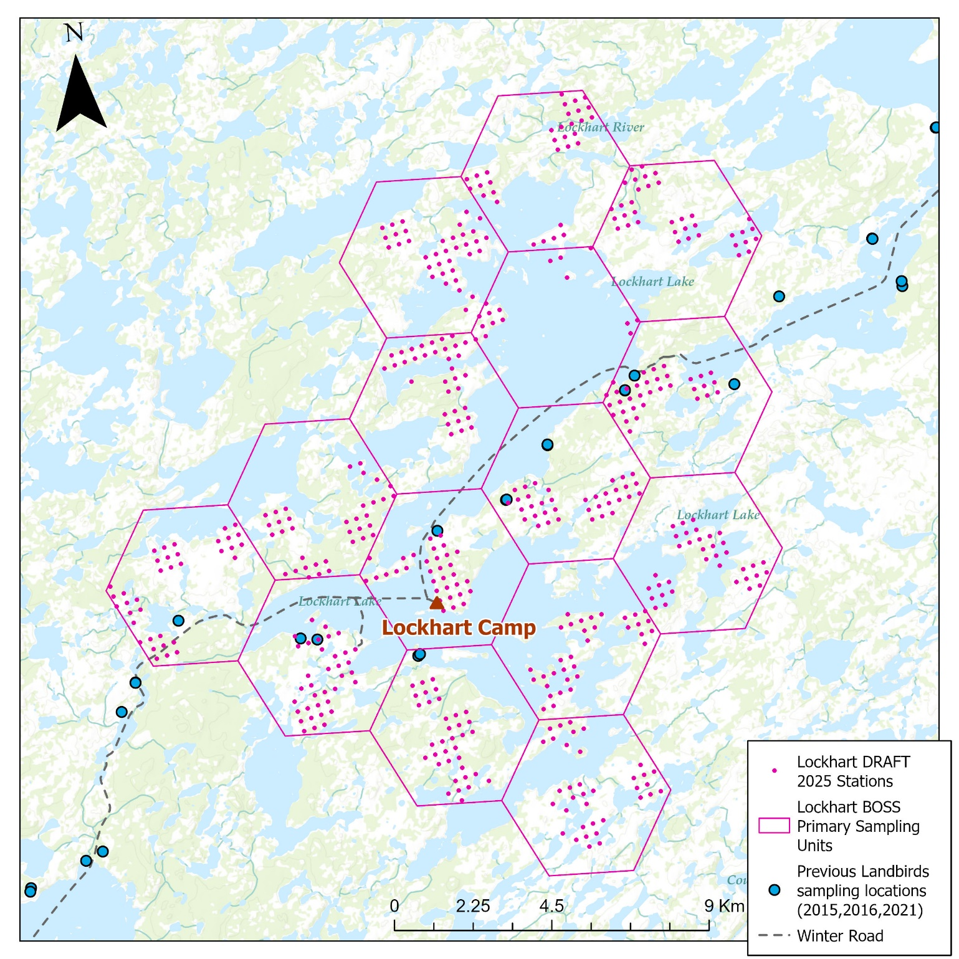
Figure 3: Potential sampling locations (pink within hexagons) around Lockhart camp and in blue are previous sampling locations where ARUs were deployed/retrieved (2015, 2016, and 2021).

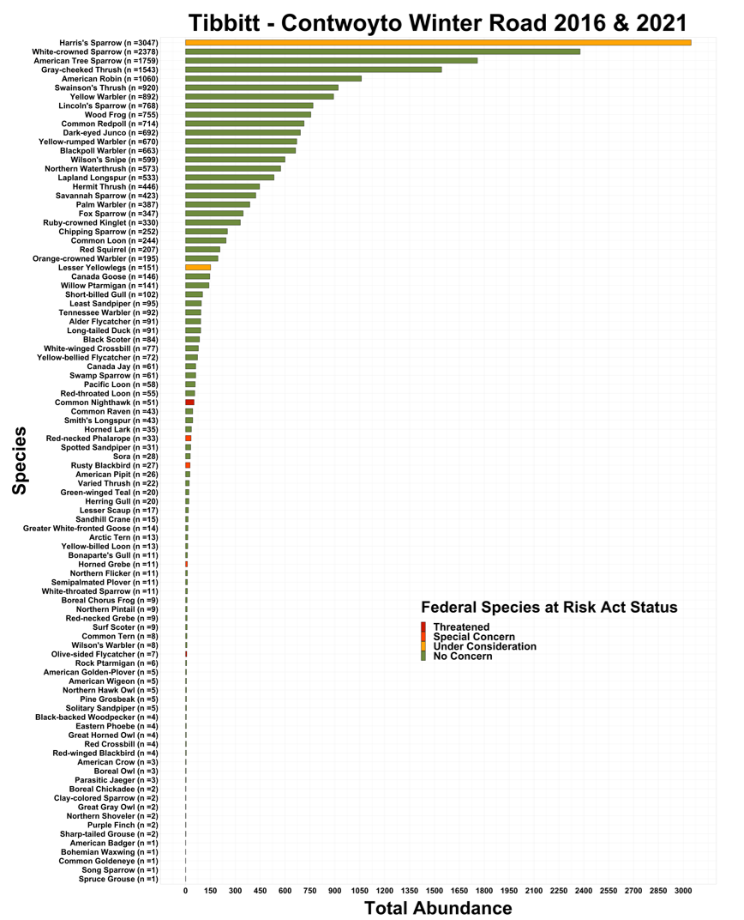
Figure 4. Total species abundance for the 80 species detected at 134 sampling locations in 2016 and 2021 along the Tibbitt to Contwoyto Winter Road. Also indicated are the conservation status of each species.

Threats boreal treeline birds: Background context
The northern treeline ecosystem provides important breeding habitat for migratory birds and is expected to undergo major perturbations resulting from human-induced climate change. Populations of several passerine species that breed at the northern treeline have undergone steep declines in North America over the last half century with several species being listed under the Species at Risk Act (SARA) or assessed by the Committee for the Status of Endangered Wildlife in Canada (COSEWIC). For example, Harris’s Sparrow is a species of Special Concern under SARA, COSEWIC has scheduled Grey-cheeked Thrush for a status report preparation for November 2023, and Blackpoll Warbler and American Tree Sparrow are on the candidate assessment lists as mid-priority and low-priority, respectively. However, population status and trend data for boreal songbirds including treeline species are mainly derived from Breeding Bird Surveys, which has very limited coverage North of 60 (Bird Conservation Regions 3, 4, 6 and 7), or from Christmas Bird Counts conducted in the United States when these species are on their wintering grounds, which cannot differentiate trends among breeding populations. While baseline population size data is being collected through existing CWS long-term monitoring projects (e.g. NWTBMP; Figure 2), generation of trend information from these programs for treeline songbirds are still years away and significant spatial gaps in monitoring coverage and research remain.
Avian research in the treeline ecosystem in Canada is limited due to logistical difficulties in working there (i.e. remote) with most studies occurring ca. 30 years ago. As a result, little is known about the breeding ecology of treeline birds and potential threats over the annual cycle. Targeted studies on treeline breeding birds including community-habitat relationships, demographics, threats during migration, and other fundamental ecological questions can ultimately help inform COSEWIC and SAR processes, conservation management, and land use planning.
Boreal breeding migratory birds including treeline species are exposed to multiple threats over the full-annual cycle. Climate change effects on the breeding grounds and increasing land use intensification (e.g. agriculture) and contaminant exposure on the non-breeding grounds are potential factors influencing population dynamics of treeline species. Migratory connectivity, the spatial connections between breeding and wintering areas can help assess the degree of population mixing and together with existing or enhanced monitoring programs can provide insight into factors driving population trends. Treeline breeding species that over-winter in agricultural areas in the United States and Latin America are potentially exposed to deleterious contaminants and land use changes that may have carry-over effects on key demographic parameters (e.g. breeding success) and survival. Additionally, spring migration coincides with agricultural sowing in the North American Great Plains during which potentially toxic pesticides (e.g. neonicotinoids) are applied and available for consumption representing an additional threat, particularly to granivorous or omnivorous ground foraging birds.

To understand factors affecting demographic parameters of birds breeding in the treeline ecosystem, the study will focus on common passerines (Table 1) breeding near Lockhart camp in the treeline ecosystem northeast of Yellowknife, NT using a modified mapping avian productivity and survivorship (MAPS) protocol (https://birdpop.org/docs/misc/MAPSManual23.pdf). Birds will be captured using passive and playback and banded in a mist-net ‘grid’ (~20 nets / 40 ha). Color bands will be applied to four focal species, Harris’s Sparrow, American Tree Sparrow, Gray-cheeked Thrush and Blackpoll Warbler. Banding and recaptures or re-sightings will occur over 3 to 4 years following the first year of banding. We will assess our ability to quantify return rates and apparent survival of individual species from these data after one to two years of data collection and incorporate multiple environmental variables into our analyses (e.g. precipitation, temperature). Depending on results from preliminary analyses, we may also try to determine if pesticides influence survival and productivity.

Table 1. Anticipated sample sizes of each treeline breeding passerine species of the study.
Species | Procedure | Anticipated Sample Sizes
Harris’ Sparrow | Capture/Band/Morphometrics | 60 (20 migration; 40 breeding)
 | Color band | 40 (breeding)
 | Feather, blood sample | 40 (20 migration, 20 breeding)
 | Fecal sample | 20 (10 migration, 10 breeding)
 | Fit Radio transmitters | 30 (breeding)
American Tree Sparrow | Capture/Band/Morphometrics | 60 (40 breeding)
 | Color band | 40 (breeding)
 | Feather, blood sample | 40 (20 migration, 20 breeding)
 | Fecal sample | 20 (10 migration, 10 breeding)
 | Fit Radio transmitters | 20 (breeding)
Blackpoll Warbler | Capture/Band/Morphometrics | 60 (20 migration, 40 breeding)
 | Color band | 40 (same birds, breeding)
 | Feather, blood sample | 30 (10 migration, 20 breeding)
 | Fecal sample | 20 (10 migration, 10 breeding)
 | Fit Radio transmitters | 20 (breeding)
Gray-cheeked Thrush | Capture/band/morphometrics | 60 (20 migration, 40 breeding)
 | Color band | 40 (breeding)
 | Feather, blood sample | 40 (20 migration, 20 breeding)
 | Fecal sample | 20 (10 migration, 10 breeding)
 | Fit Radio transmitters | 20 (breeding)
Other songbirds: White-crowned Sparrow, Wilson’s Warbler, Dark-eyed Junco, Common Redpoll, Yellow-rumped Warbler | Capture using mist nets/band (metal)/morphometrics | 300 (100 migration, 200 breeding)
 | Feather sample | 50 (same birds; ~10/species, breeding)
We will also assess migratory connectivity using VHF radio-transmitters fit to birds on the breeding grounds, which can be detected using the Motus receiver network (https://motus.org/) distributed across many parts of southern North America (Figure 2). This part of the study will also target Harris’s Sparrow, American Tree Sparrow, Blackpoll Warbler and Gray-cheeked Thrush. This technology requires that focal species are tagged on the breeding grounds to be detected on the non-breeding grounds. We are also planning on deploying a Motus receiver at the study site (Figure 1), which will allow us to determine apparent survival and departure dates for tagged individuals. There is currently only one Motus tower within the Canadian boreal-Arctic treeline. In future years, we plan on deploying tags and expanding the network of Motus receivers across the breeding range of these “treeline species”.
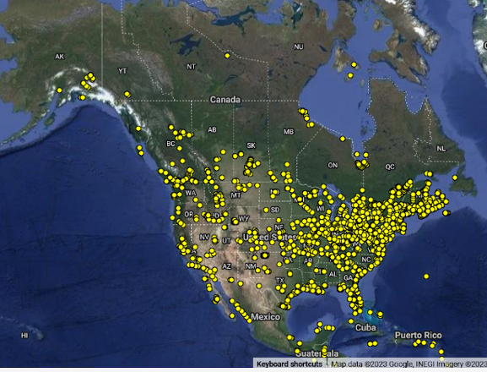
Figure 6. Locations of current and historic Motus towers in North America. The single tower in the Northwest Territories is located at Daring Lake within the treeline ecosystem.

Stable isotopes are incorporated into animal tissues via diet and drinking water and provide useful information on where the tissue was grown. Feathers are especially useful because stable isotope profiles are ‘locked in’ once formed therefore feathers sampled away from the region of growth (e.g. during migration) can be used to estimate likely origins. Thus, determining origins using isotopic assignment therefore requires capturing and sampling an individual only once. To help assess migratory connectivity during migration, feathers (one tail feather, R3) will be sampled during migration near Saskatoon, SK, but feathers will also be sampled from multiple passerine species on the breeding grounds in the treeline ecosystem to provide isotopic values for these species in our study area.
Diet and isotope niche (a proxy for ecological niche) of the four species will be investigated using fecal and feather samples. Fecal samples are assayed using metabarcoding which provides an assessment of up to species level insect identification. Along with δ²H_{f}, which provides an indication of aquatic diet sources, carbon (δ¹³C_{f}) and nitrogen (δ¹⁵N_{f}) will also be analyzed providing additional information on aquatic sources and trophic level, respectively. Only one feather sample is required for analysis of all three isotopes therefore feathers collected during the breeding season, and fecal samples collected during breeding and migration seasons will be used for these assays. Feces provide an assessment of diet in the previous hours and feathers provide a measure of isotope niche during the period of feather growth (~10 days).
To assess the potential toxic or negative sub-lethal effects of pesticide exposure over the non-breeding season and during migration through agricultural regions, we will sample blood of the four target species for neonicotinoid assays. Sampling will occur during the breeding season at our boreal treeline study site and during spring migration near Saskatoon, SK. This will allow assessing neonicotinoid exposure during spring migration and pesticide retention over the breeding season. Concentrations of neonicotinoids in blood plasma will be compared among the four species, which have different diet and foraging behaviors, the two sparrow species are omnivorous and the warbler and thrush species are insectivorous, which potentially exposes each species to different levels of neonicotinoids. Specifically, the goals of this research program are to:

1) Migratory Connectivity: Assess spatial linkages between breeding and non-breeding areas of adult birds using feather stable isotopes and miniaturized radio tags. Focal species: Harris’s Sparrow (Zonotrichia querula), American Tree Sparrow (Spizelloides arborea), Blackpoll Warbler (Setophaga striata) and Gray-cheeked Thrush (Catharus minimus).

2) Contaminants: Assess neonicotinoid pesticide exposure in adult birds during spring migration and carryover to the breeding season.

3) Diet and trophic partitioning: Use fecal metabarcoding and stable isotopes as proxies for diet and trophic partitioning and positioning of multiple common bird species.

4) Breeding demographics: Determine factors influencing productivity, return rates, and survival of birds captured at a boreal forest – Arctic tundra ecotone (northern “treeline”) breeding site in the Northwest Territories. Focal species: all passerine species captured using this protocol.

Proposed research and monitoring activities
NWT Biodiversity Monitoring Program
In June and July 2025, we are proposing to work with communities members to deploy acoustic recording units (ARUs) and wildlife cameras at ~ 60 sampling locations (~ 12 sites) located in different habitat types in 20 km buffer around Lockhart camp (Figure 3). Bat meters and temperature loggers would also be deployed at a subset of ~ 12 sampling stations (~ 1 per “deployment site”). Sites would be accessed by boat and foot. Sensors will be deployed for approximately 1 year. Therefore, units would be retrieved in fall 2026 at the latest. Specific sampling locations to be accessed, avoided or added and more adequate mean of transportation (minimize disturbance for wildlife) to do the work would be determined based on appropriate engagement with members from Yellowknifes Dene First Nation, North Slave Métis Alliance, Wek'eezhii Renewable Resources Board, and Łutsel K’e Dene First Nation.
The proposed recording schedule for each ARU would be as follow (but could be modified to meet other needs from our co-management partners):

May 1st - June 30th
- 1 hour before sunset to 4 hours after sunrise: 10 minutes/hour

July 1st – August 15th
- 1 hour before sunset: 10mins
- @ sunset: 10m
- 2 hours after sunset: 10mins
- 1 hour before sunrise: 10mins
- @ sunrise: 10m

August 15th –September 30th
- 1 hour before sunset: 10mins
- @ sunset: 10mins
- @Midnight: 10mins
- 1 hour before sunrise: 10mins
- @ sunrise: 10mins

The raw data for this project would consist of ~ 6,840 hrs of soundscape recordings (~ 114 hrs per long-term deployment sampling station) and up to ~ 1,500,000 pictures, including many animal detections during the ~ 1-year period. The raw data, as well as the results from data transcription and subsequent data products (results from statistical analyses; e.g. Figure 7), will be shared among all program collaborators.

Threats boreal treeline birds
Sampling for this project will be conducted during migration, ~May 5 – 20 (Saskatoon, SK), and during the breeding season ~June 22 – July 15 (Lockhart camp northeast of Yellowknife; Figure 3). We will conduct a pilot study in 2025 and, depending on the results, will aim to increase sampling effort in 2026 – 2029. Samples will be analyzed in the fall and winter following the year of collection and manuscripts will be submitted for publication in scientific journals following completion of analyses and meaningful engagement with our indigenous partners.

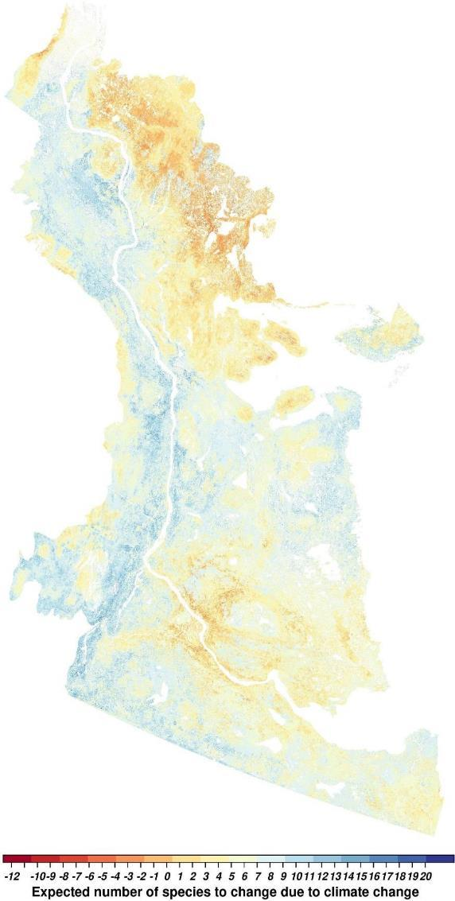

Figure 7. Results identifying areas where the number of landbird species will potentially increase (blue) or decrease (red) by the end of the century in response to climate change (Frontiers | Assessing Pathways of Climate Change Effects in SpaDES: An Application to Boreal Landbirds of Northwest Territories Canada (frontiersin.org)). This is an example of how data from the NWT Biodiversity monitoring program and other monitoring programs contribute to better understanding current and future potential status of landbirds in the NWT and across North America (see also State of the Birds 2022, Home - Wild Species: The General Status of Species in Canada, and Boreal Avian Modelling Project / Results - BAM Species Models (borealbirds.github.io)).

